Elakeview Enterprise LTD
LED Linear Strip Fixture

LED Linear Strip Fixture is designed for surface and suspended mounting for indoor use. Its narrow strip design, sleek and modern profile work perfectly for task lighting applications where high efficiency, row mounting is required. Suitable for damp locations.
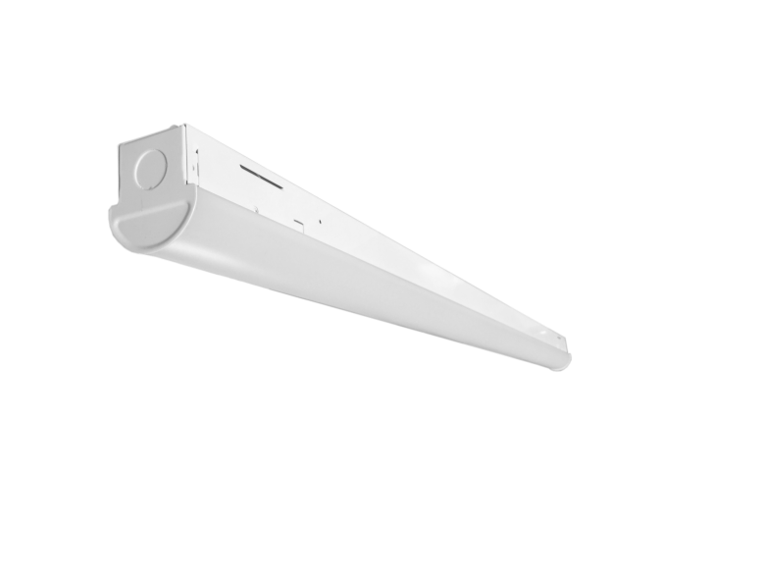
LED Linear Strip AC120-277V

Features
- Wide input voltage options from 120-277V and 347V
- Narrow, sleek and modern profile. High impact polycarbonate lens
- High lumen efficiency and low glare
- Power entry on either end or real of fixture
- Can be surface mounted , or chain suspended
- 0-10V dimming,

Options

- 2’, 3’ ,4’ and 8’ lengths available
- motion/dimming motion sensor available
- 3500K,.4000K and 5000K available

Construction
- White steel housing
- Access panel for easy wiring
- IP20 rated

Approvals
- cUL listed
- DLC listed
- Dry and Damp location rated

Operating Temperature
- -20 C to 40C

Warranty
- Standard 5 years. Extended warranty available

◊ Specifications & Order info

Order SKU | Model No. | Description | Input Voltage | Dimension | Weight
900051 | ST2F20WUNV40K | LED Strip 2ft 20W, AC120-277V, 2600LM, 4000K, 0-10V dimming, | AC120-277V | 22.2’’x2.36’’x2.8’’ | 0.85kg
900052 | ST3F25WUNV40K | LED Strip 3ft 25W, AC120-277V, 3250LM, 4000K, 0-10V dimming, | AC120-277V | 35.04’’x2.36’’x2.8’’
900053 | ST4F18WUNV40K | LED Strip 4ft 18W, AC120-277V, 2358LM, 4000K, 0-10V dimming, | AC120-277V | 47.32’’x2.36’’x2.8’’ | 1.7kg
900054 | ST4F18WUNV50K | LED Strip 4ft 18W, AC120-277V, 2376LM, 5000K, 0-10V dimming, | AC120-277V | 47.32’’x2.36’’x2.8’’ | 1.7kg
900055 | ST4F35WUNV35K | LED Strip 4ft 35W, AC120-277V, 4585LM, 3500K, 0-10V dimming, | AC120-277V | 47.32’’x2.36’’x2.8’’ | 1.7kg
900056 | ST4F35WUNV40K | LED Strip 4ft 35W, AC120-277V, 4655LM, 4000K, 0-10V dimming, | AC120-277V | 47.32’’x2.36’’x2.8’’ | 1.7kg
900057 | ST4F35WUNV50K | LED Strip 4ft 35W, AC120-277V, 4725LM, 5000K, 0-10V dimming, | AC120-277V | 47.32’’x2.36’’x2.8’’ | 1.7kg
900058 | ST8F38WUNV40K | LED Strip 8ft 38W, AC120-277V, 5054LM, 4000K, 0-10V dimming, | AC120-277V | 94.17’’x2.36’’x2.8’’ | 3.4kg
900059 | ST8F65WUNV40K | LED Strip 8ft 65W, AC120-277V, 8775LM, 4000K, 0-10V dimming, | AC120-277V | 94.17’’x2.36’’x2.8’’ | 3.4kg

Last revised 08/13/18 www.aaoptoelectronics.com

